Colors:

1. White
2. Light Green
3. Light Red

Images:

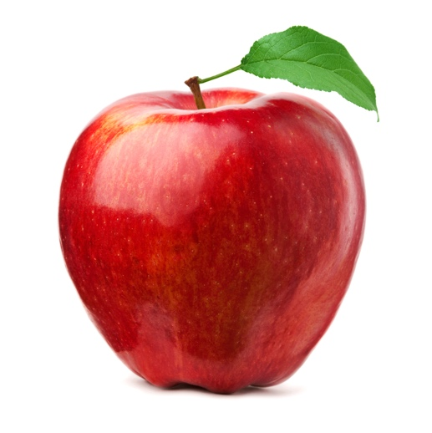

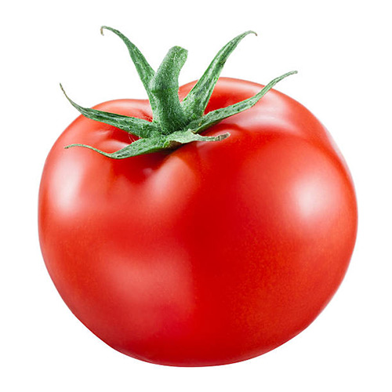

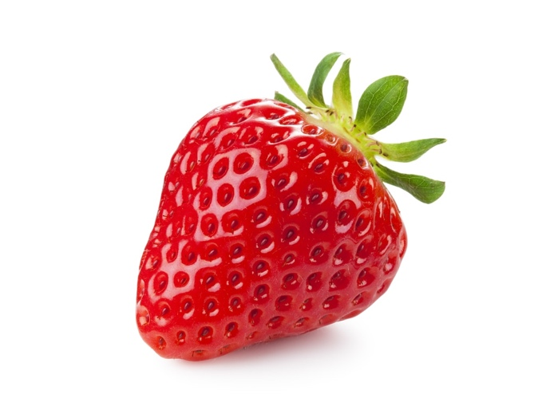

Fonts:

1. Fira Sans Type Specimen
2. Libre Franklin Type Specimen